**ASSIGNMENT 4**

**Name:** Shameer Shaik

**Student ID:** 7007405840

**CRN:** 21627

**GitHub link:** <https://github.com/SHAMEERSHAIK7/Machine-Learning-CS-5710>

**Video link:** <https://vimeo.com/815234954/2838e72c27>

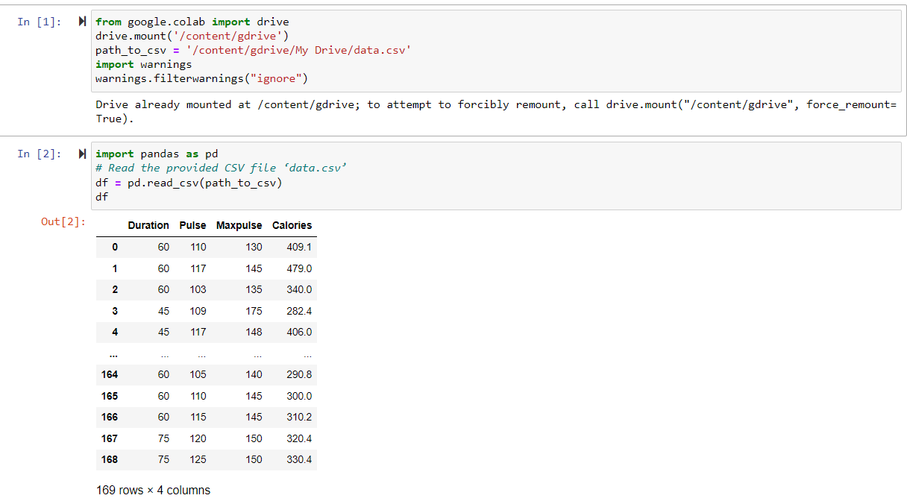

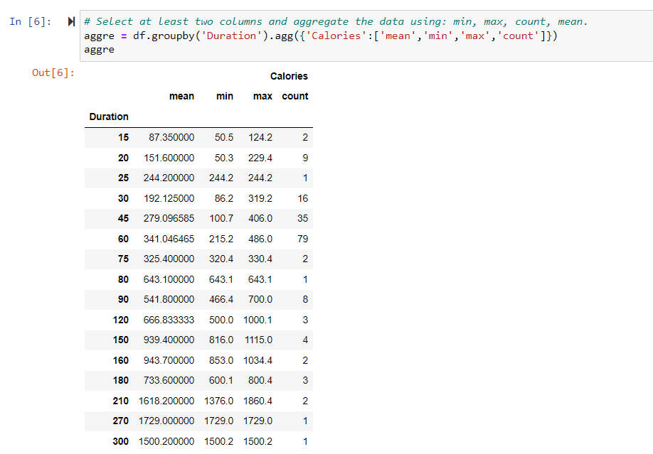

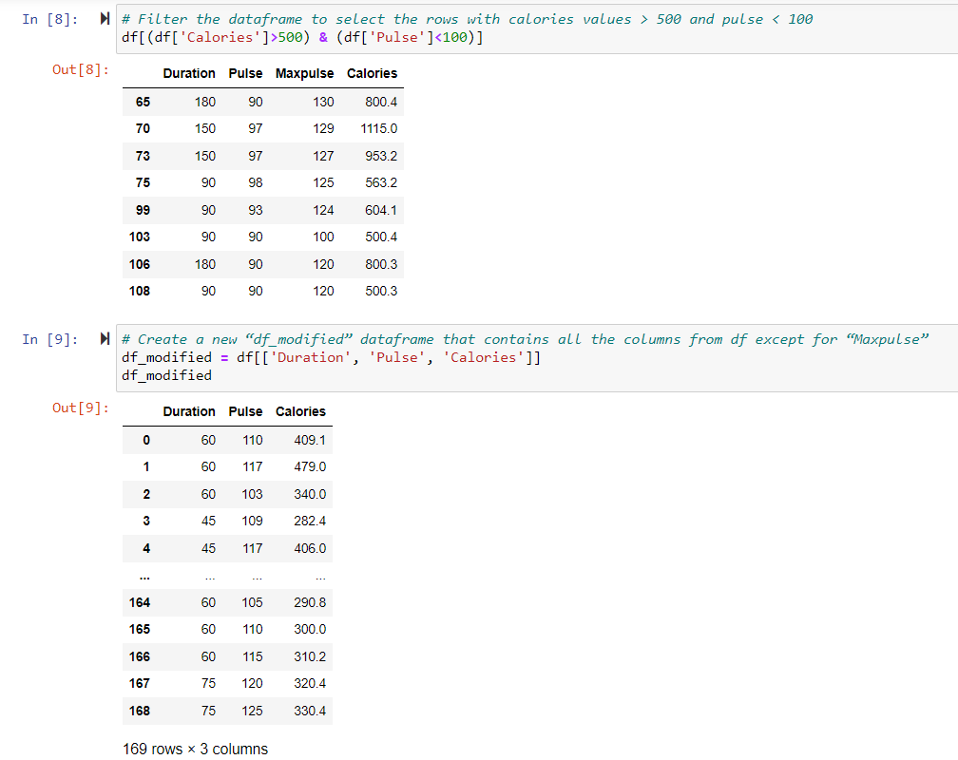

**Titanic Dataset:**

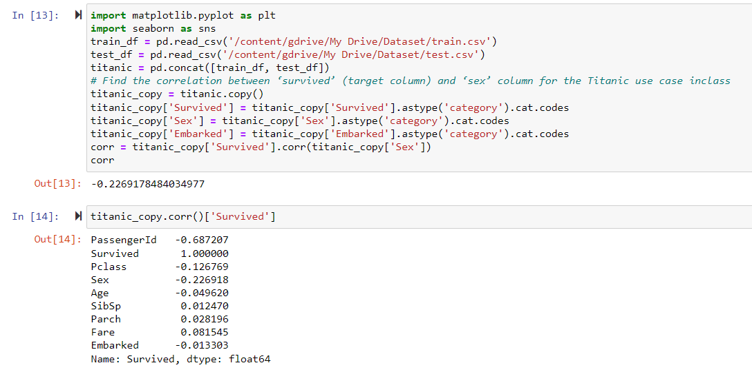

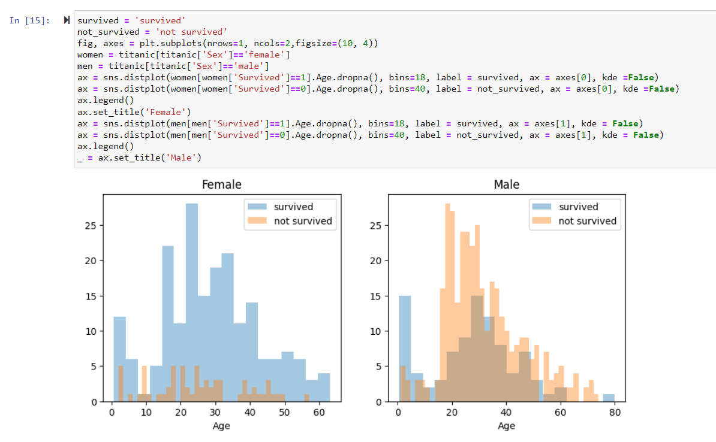

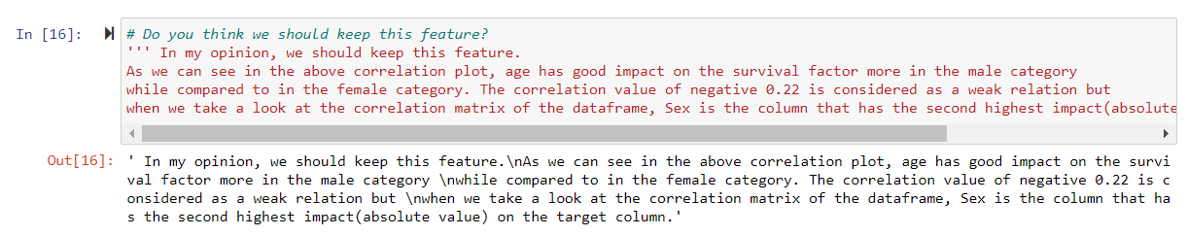

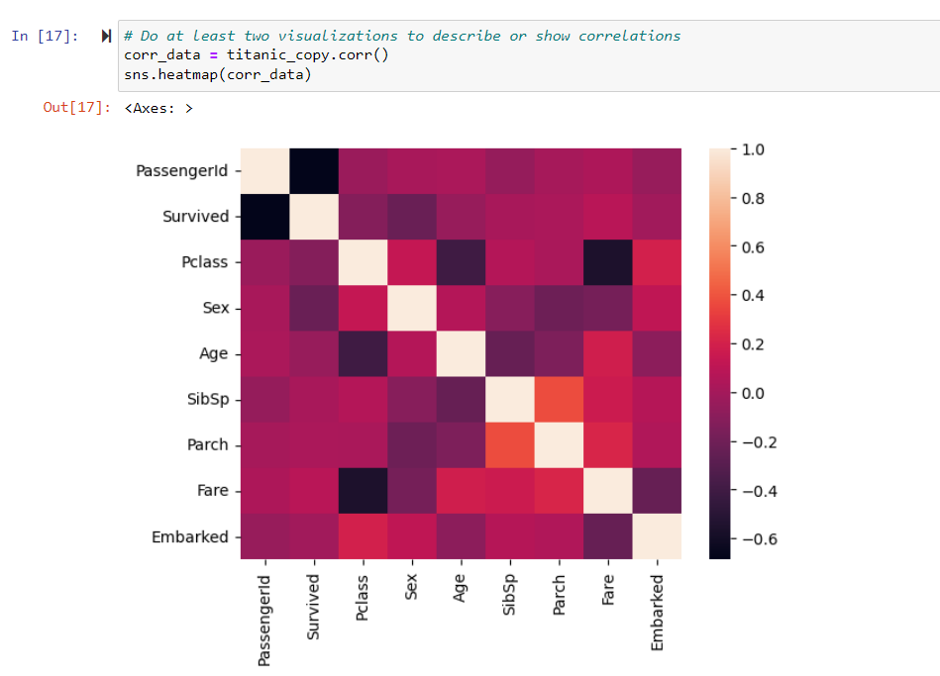

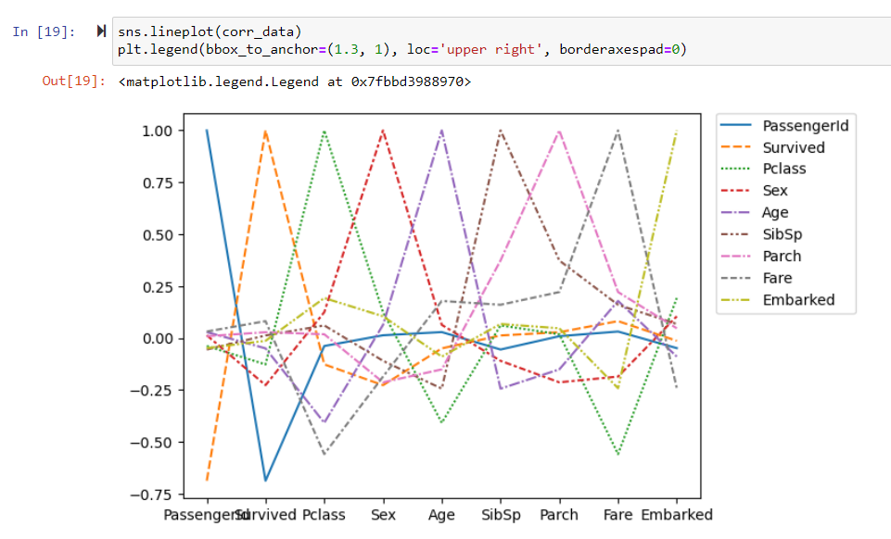

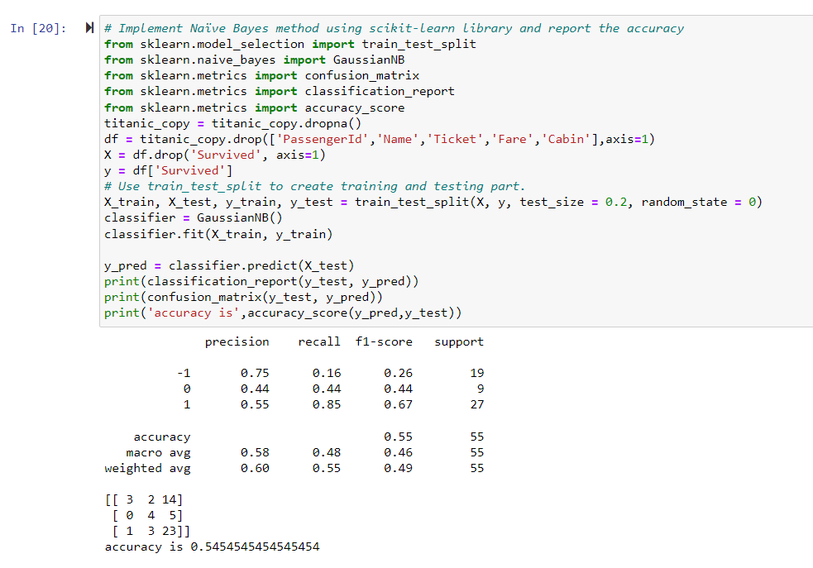

**Glass dataset:**

The algorithm in the Naïve Bayes method using scikit-learn library has better accuracy than the linear SVM method using scikit library. The Naive Bayes algorithm is extremely quick. It is based on conditional probabilities, which are simple to use and assess.

As a result, an iterative approach is not needed. When it comes to non-linear classification jobs, SVM is more effective. In high dimensional spaces, such as those corresponding to literature, SVM generalizes well.